BLG 105E

3rd Homework

To Do: Two different matrices will be read from text files (input1.txt, input2.txt) and they will be stored in two dimensional arrays (matrix1, matrix2) and one dimensional arrays (array1, array2). Our aim is to obtain the matrix multiplication using two dimensional and one dimensional arrays.

You are asked to write the main and the following functions. The definitions of the functions are given in the skeleton code.

int read_file(ifstream& in_file, int &row, int &col, double *array, double **matrix)
int write_file(ofstream& out_file, int row, int col, double **matrix)
void print_matrix(double **matrix, int row, int col)
void print_array(double *array, int row, int col)
void multip(double **matrix1, double **matrix2, double **result, int k, int m, int n)
void multip_array(double *array1, double *array2, double *array_result, int k, int m, int n)

You are going to obtain the input and output files as command line arguments.

Example run of the program:

$ ./HW3 input1.txt input2.txt result.txt

Example output of the program:

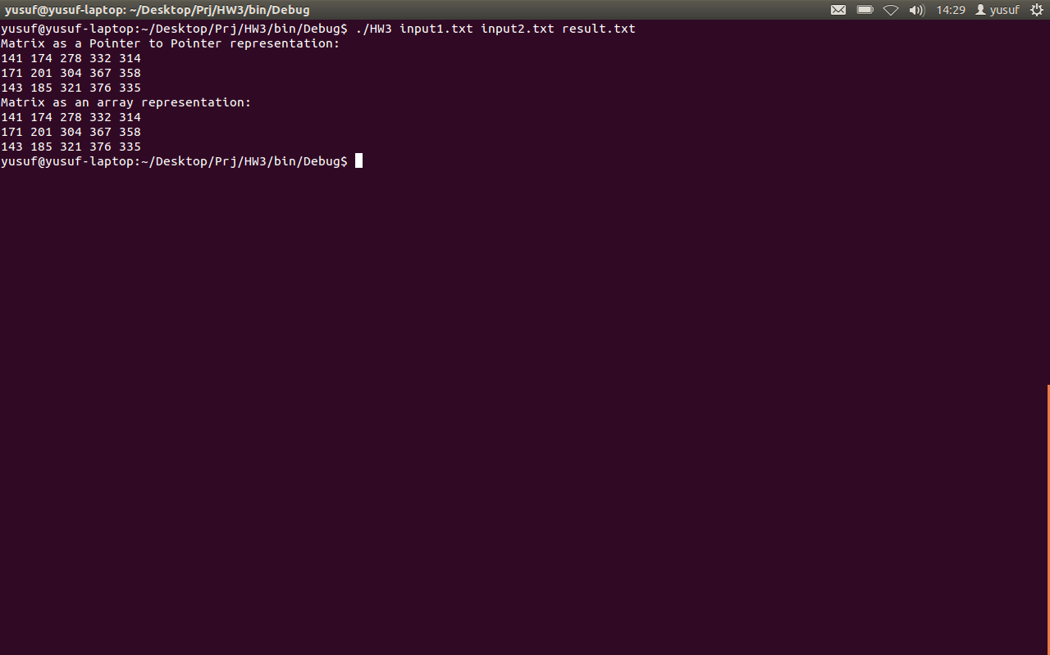

Input file formats:

A sample input file may contain the following elements (Sample files are edited under linux and they contain linux line ending. Line ending of linux files is different from Windows files. Therefore under Windows OS open the input.txt files with wordpad):

3 4
2 3 4 5
1 3 5 4
0 4 4 7

The first element in the first line represents the number of rows (3) and the second element represents the number of columns (4) of the matrix (the result file will have the same format).
The following lines are the matrix elements as follows:

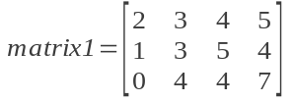

Note: You are expected to write C++ codes that can be compiled by g++ under Linux.

Deadline: 27 May 2012, 24:00

Skeleton Code of the Homework

#include <iostream>
#include <fstream>
#include <string>

using namespace std;

int read_file(ifstream& in_file, int &row, int &col, double *array, double **matrix)
{
//Reads elements of a matrix from a in_file and stores the elements into one
// dimensional array and two dimensional matrix parameters.
// row and col parameters represents the number of rows and columns of the matrix.
}

int write_file(ofstream& out_file, int row, int col, double **matrix)
{
// Writes the elements of a matrix to out_file
// row and col parameters represents the number of rows and columns of the matrix.
}

void print_matrix(double **matrix, int row, int col)
{
//Prints the elements of a matrix to the screen.
}

void print_array(double *array, int row, int col)
{
//Prints the elements of a matrix (matrix is represented as an array) to the screen.
}

void multip(double **matrix1, double **matrix2, double **result, int k, int m, int n)
{
// Function that multiplies two dimensional arrays
matrix1(size: kxm) and matrix2 (size: mxn).
// Results are stored in the result (size: kxn) matrix
// You can use pointer arithmetic or matrix notation for multiplication.
}

void multip_array(double *array1, double *array2, double *array_result, int k, int m, int n)
{
//multiplies one dimensional arrays array1(size: 1x(kxm)) and array2 (size: 1x(mxn)) by using
//pointer
arithmetic and stores the results at one dimensional array array_result (size: 1x(kxn)).

}

int main(int argc, char* argv[])
{
// Input and output files will be obtained from user using argv.
int row1, col1, row2, col2;
//row1 and col1 will be read from first line of the input file1
//row2 and col2 will be read from first line of the input file2

// Two dimensional arrays can be defined using pointer to pointers:
double **matrix1, **matrix2, **result;
// Dynamic memory allocation for two dimensional arrays:
matrix1 = new double *[row1];
for (int i = 0; i < col1; i++)
matrix1[i] = new double [col1];
//You can access the elements of the two dimensional arrays using matrix notation: matrix1[i][j] or
// pointer arithmetic: *(*(matrix + i) + j)

read_file(in_file1, row1,col1,array1,matrix1); // Read the first file
read_file(in_file2, row2,col2,array2, matrix2); // Read the second file

//Multiply the two matrices using two dimensional matrices
multip(matrix1, matrix2, result, row1, col1, col2);

// Multiply the two matrices using one dimensional arrays
multip_array(array1, array2, result_array, row1, col1, col2);

//print out the result matrix
print_matrix(result, row1, col2);
// print out the result array
print_array(result_array, row1, col2);

// Write the result of the multiplication (result matrix) to a file
// File name will be obtained from the user
write_file(out_file, row1, col2, result);
return 0;
}

